React Lab Report - EventExamplesApp

# Introduction

This lab focuses on handling events in React, such as button clicks, synthetic events, and using arguments with functions.

# Objectives and What I Learned

- Handle React events using onClick

- Use multiple methods on a single event

- Pass arguments to event handlers

- Use synthetic events like onPress

- Implement a currency converter using button click

# Hands-on Practice Summary

Created 'eventexamplesapp' to demonstrate event handling. Included counter increment/decrement, custom welcome alert, synthetic events, and INR to Euro currency conversion.

# Code Snippets

**App.js**

import React, { Component } from 'react';  
class App extends Component {  
 constructor(props) {  
 super(props);  
 this.state = { counter: 0, rupees: '', euro: '' };  
 }  
 increase = () => { this.setState(prev => ({ counter: prev.counter + 1 })); this.sayHello(); }  
 decrease = () => { this.setState(prev => ({ counter: prev.counter - 1 })); }  
 sayHello = () => { alert("Hello!") }  
 sayWelcome = (msg) => { alert("Welcome Message: " + msg); }  
 handleClick = (e) => { alert("I was clicked! " + e.type); }  
 handleRupeesChange = (e) => { this.setState({ rupees: e.target.value }); }  
 handleSubmit = () => { const euro = (this.state.rupees / 90).toFixed(2); this.setState({ euro }); }  
 render() {  
 return (  
 <div>  
 <h1>Event Examples</h1>  
 <button onClick={this.increase}>Increment</button>  
 <button onClick={this.decrease}>Decrement</button>  
 <button onClick={() => this.sayWelcome("React!")}>Say Welcome</button>  
 <button onClick={this.handleClick}>Synthetic Event</button>  
 <input type="number" onChange={this.handleRupeesChange} />  
 <button onClick={this.handleSubmit}>Convert</button>  
 <p>EUR: {this.state.euro}</p>  
 </div>  
 );  
 }  
}  
export default App;

# Screenshot

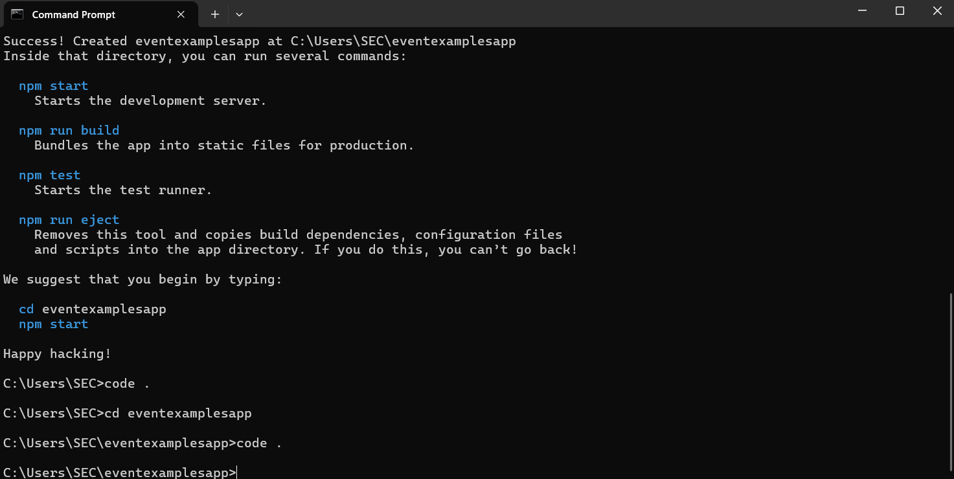

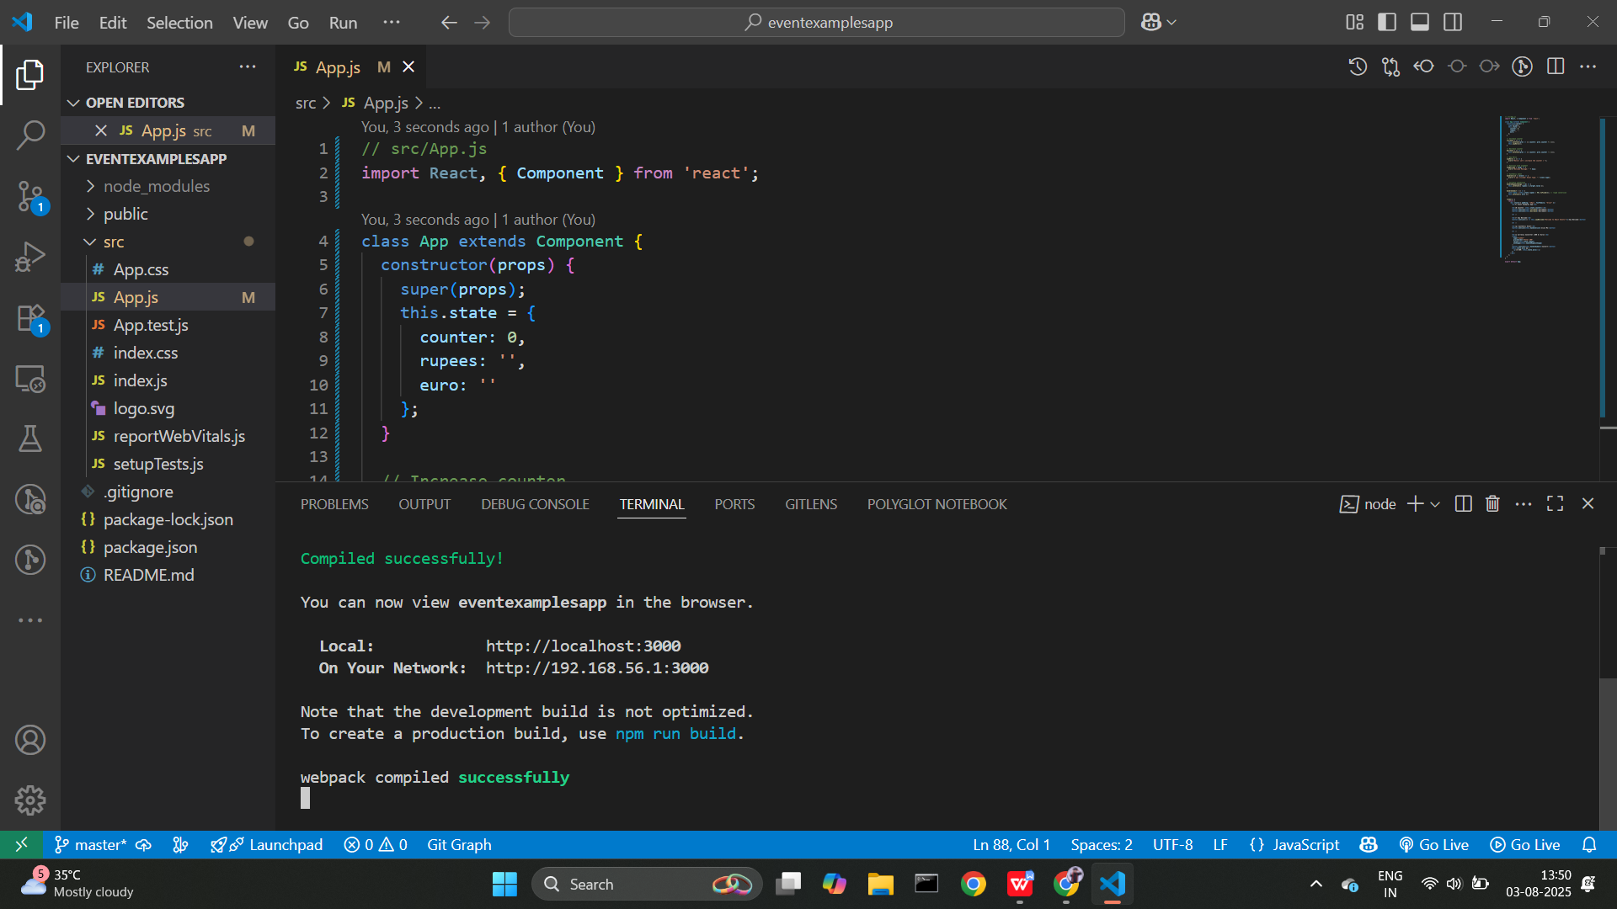

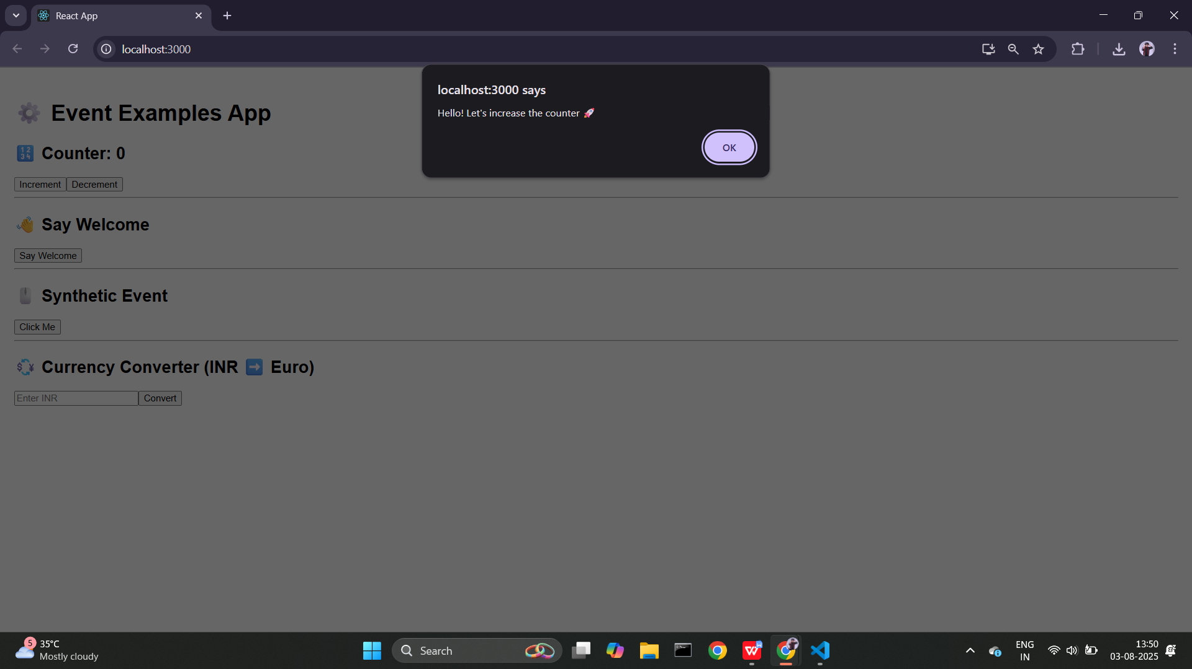

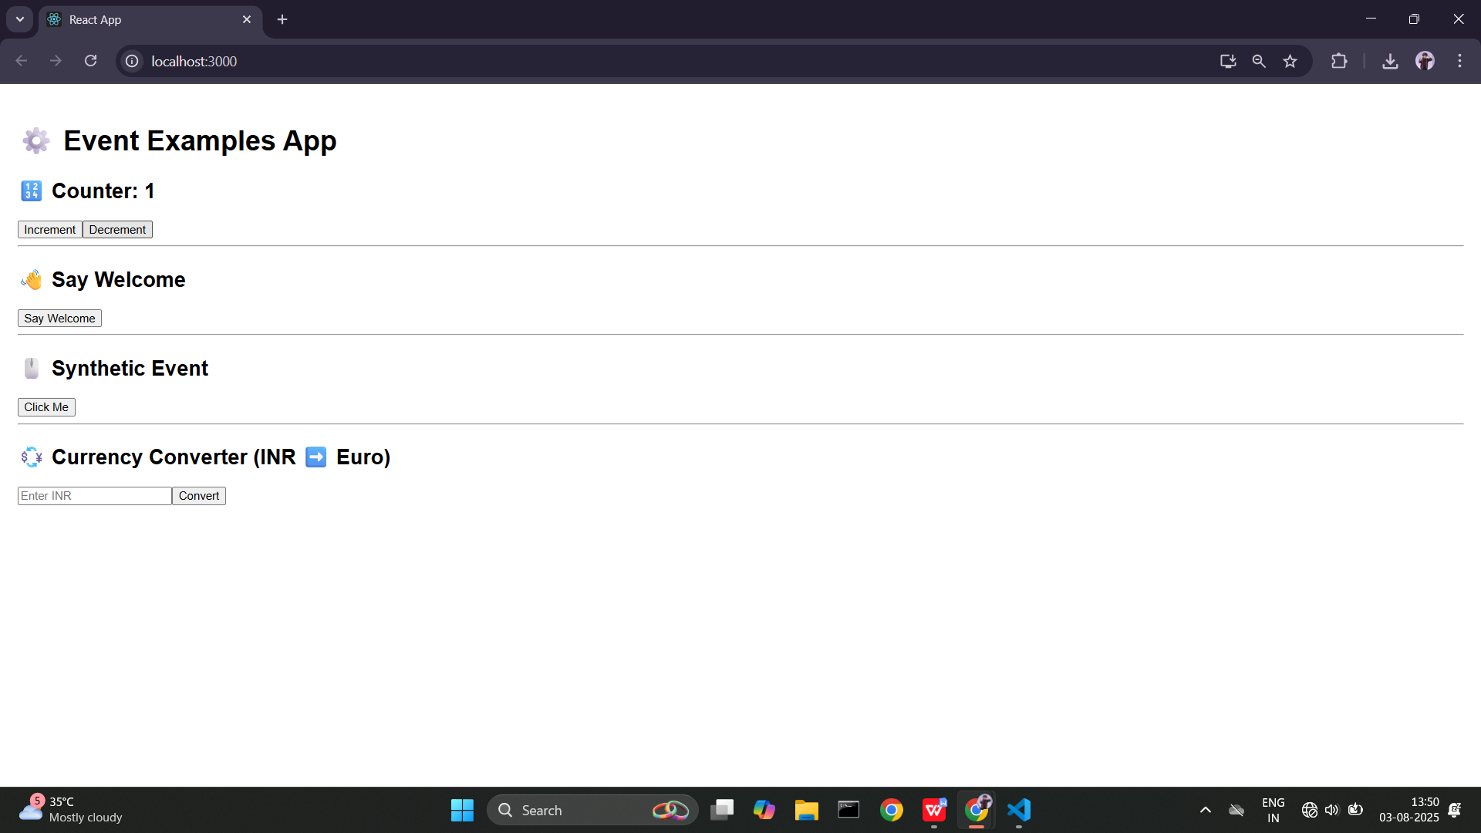

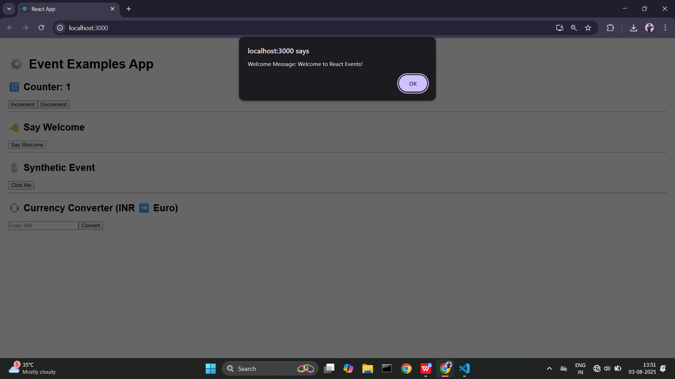

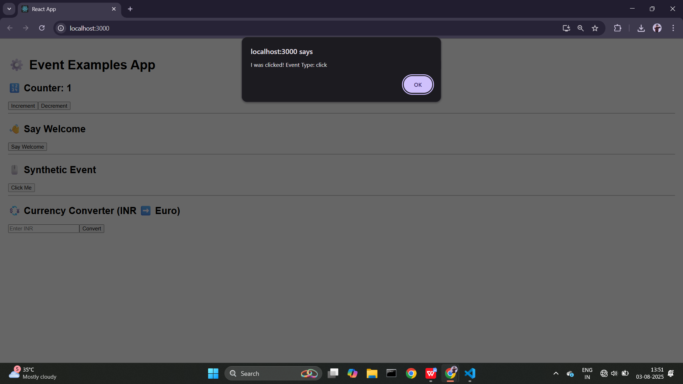

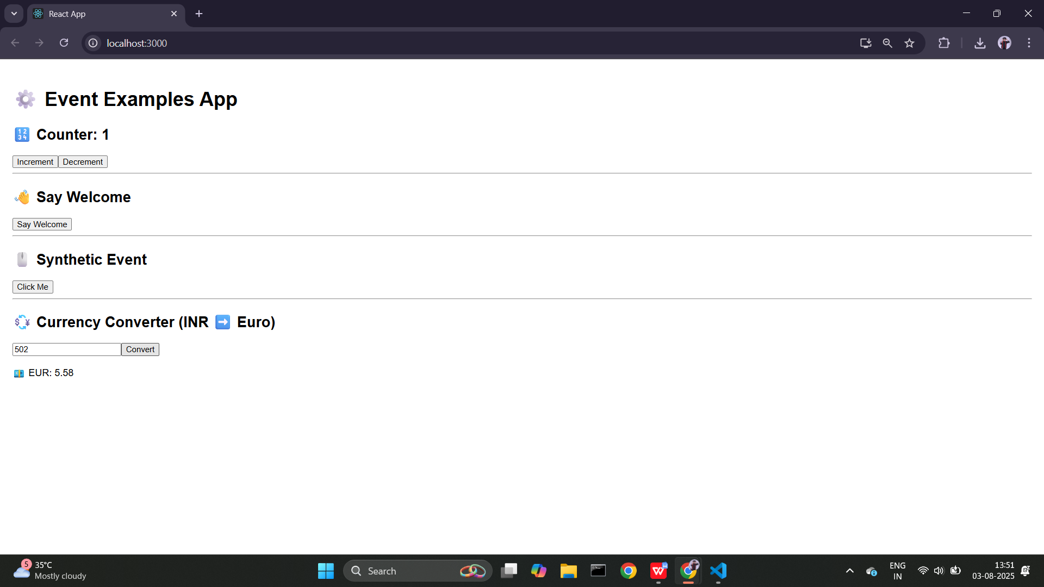

# Conclusion

This lab helped me understand how to handle events, bind methods, pass arguments, and update component state based on user actions.